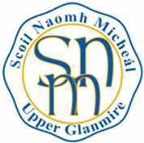
Scoil Náisiúnta Naomh Micheál
Upper Glanmire
White’s Cross
Co. Cork
Roll No: 15792U

Phone: 021-4308885
www.upperglanmirens.ie
E-mail: secretary@upperglanmirens.ie
principal@upperglanmirens.ie

Application for Enrolment - 2023

Name of child:_________________________________________________________________________

Address:______________________________________________________________________________

Date of Birth:__________________________________________________________________________

Parents / Guardians Names: ______________________________________________________________

Contact Number: ______________________________________________________________________

E-mail:_______________________________________________________________________________

Siblings already attending or who have attended Scoil Náisiunta Naomh Micheál (if applicable):

____________________________________________________________________________________

Signature of parent(s) / guardian(s): __________________________________

__________________________________

Date: ___________________

- Please note that returning this form does not guarantee an offer of a place in our school. Offers are subject to our Enrolment Policy which is available on our website or through our school office.
- This is not an Enrolment Form

