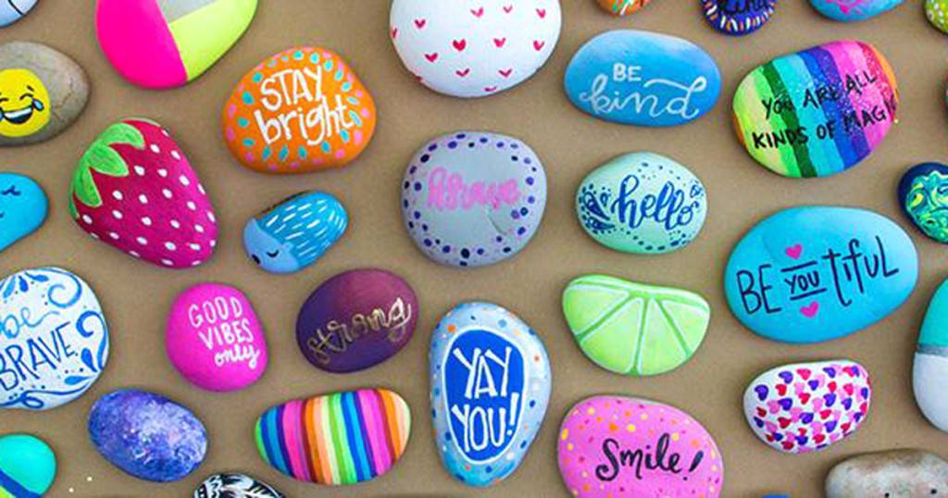
8th February 2021

Hi everyone,
I hope that you all had a good week last week and that you are keeping healthy and well. It is the beginning of Spring so I have included some Nature Art for you to do this week. Maybe you might get out for a walk with your family and scavenge some objects for your artwork.
You are doing amazing work, so well done for that great effort and engagement with your teachers. Keep it up! You made great contributions to the Zoom call last Friday. I really enjoyed hearing from you all.
Should you like to contact me, you can email me at h.carney@upperglanmirens.ie

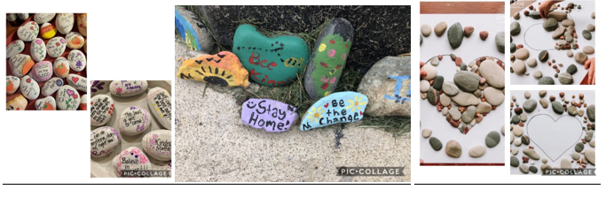
The following are just suggestions of some areas that you might like to further develop in yourself. But remember they are merely suggestions as I know that you already have a busy class schedule.
BAKING
Try these baking activities. It will revise your procedural genre and it will help you to follow instructions.
Baking is a great tactile activity which promotes hand eye coordination, fine motor skills, measuring and counting and so much more!
As well as all of the above, it is fun and the results are delicious! 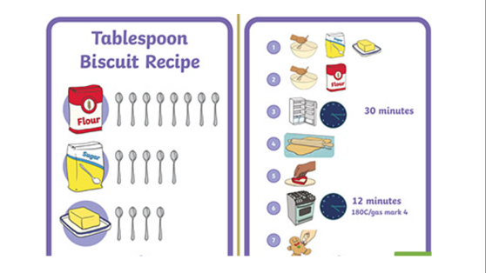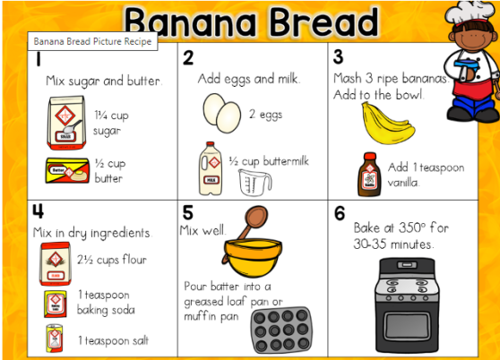

GROSS MOTOR SKILLS:
Check out this activity to keep you moving and to get those gross motor skills done.
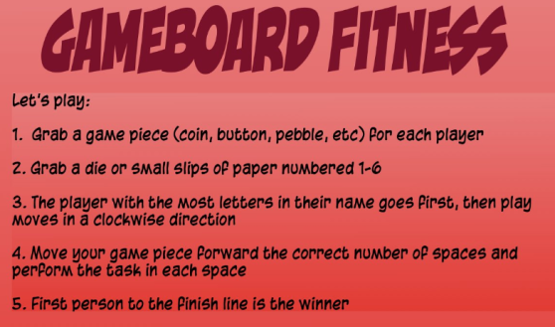
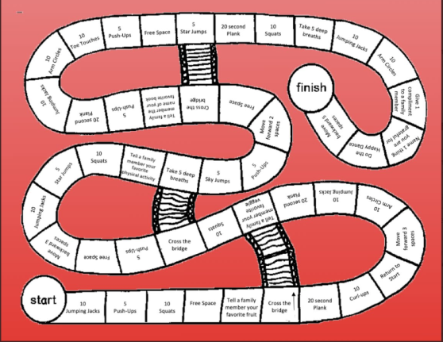
Try these yoga poses to stretch out those tired muscles after a long day of classwork!
Remember you are a great person and you are all of these things that I mention below.

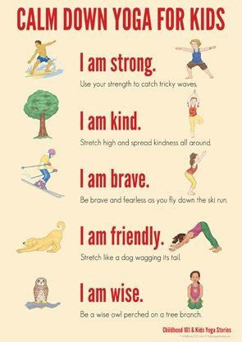

ART:
Go on a scavenger hunt around your garden and try to make these fantastic leaf bugs.
It will develop your pincer grip and fine motor skills.
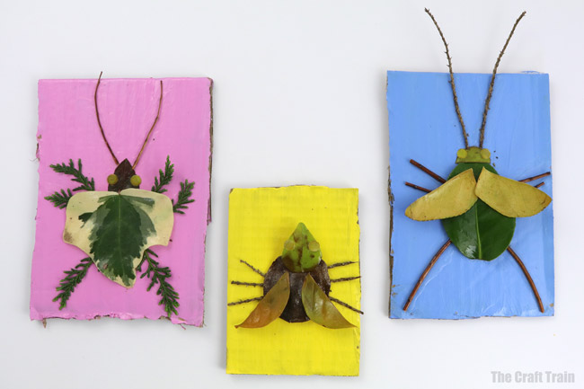

Experiment with these art ideas and have fun.
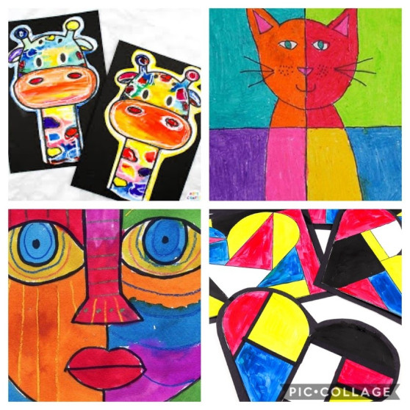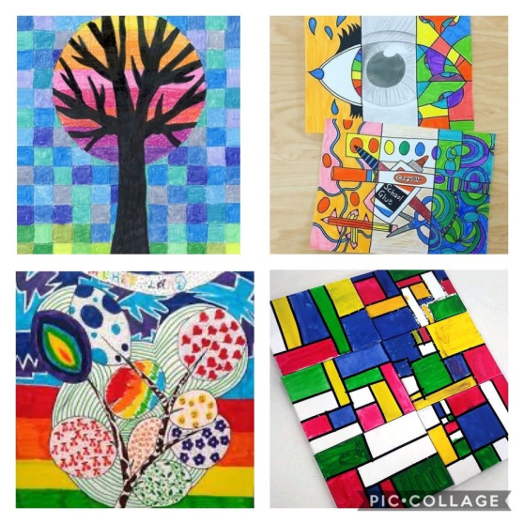
If you get out for a nice walk within your 5Km area, try to collect some items for Nature Art. Use a mixture of drawing and sticking to make a unique and personally designed nature picture.

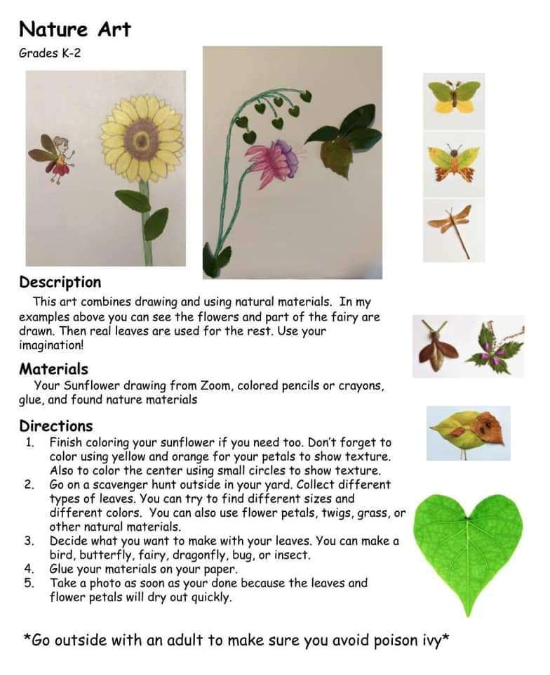
Have a great week! Remember you can only do your best and be very proud of your best effort.
We will get through this together. Stay safe and be well.

