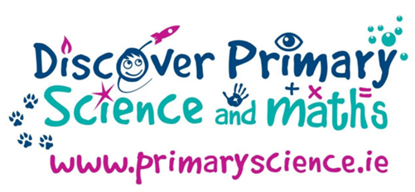

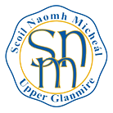

Scoil Náisiúnta Naomh Micheál
Upper Glanmire, White’s Cross. Co. Cork
Science Foundation Ireland
Discover Science & Maths Award
Application 2018
Award Number: C059

Step 1 – Science
- Energy and Forces
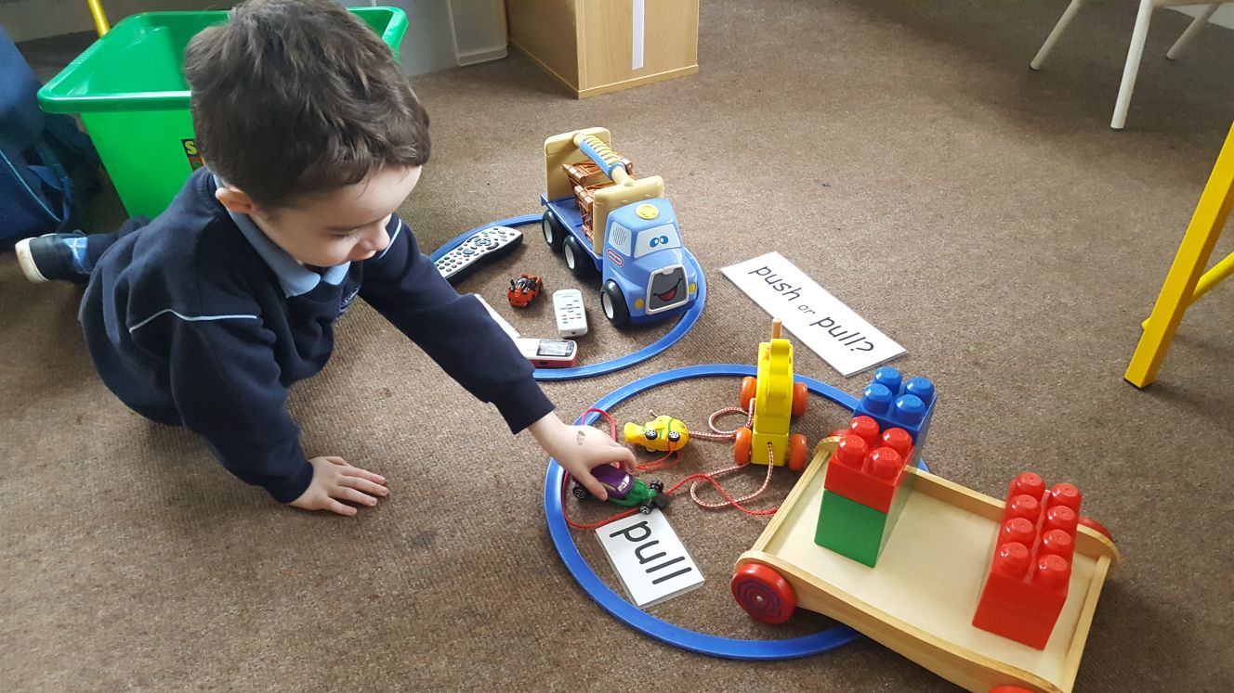
Children in our ASD classroom took part in an experiment where they explored through informal activity with toys, the forces of pushing and pulling.

- Materials
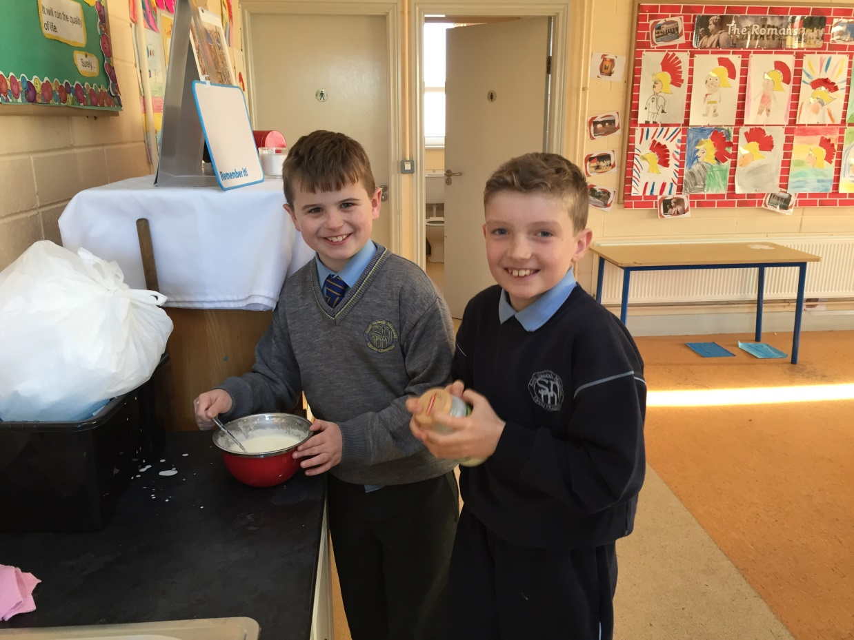
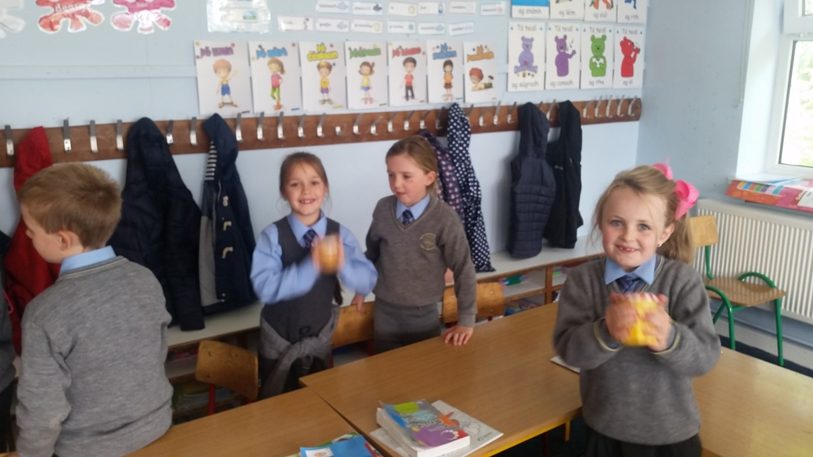

Children in our 2nd class and our 3rd/4th class made their own butter from cream and using a classroom full of strong arms!

- Living Things
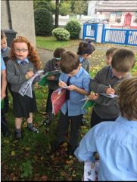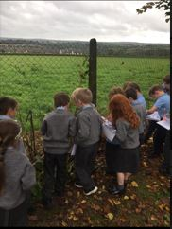
Our Senior Infants completed a nature walk where they observed, discussed and identified a variety of plants and animals in different habitats in the immediate environment.

- Environmental Awareness and Care
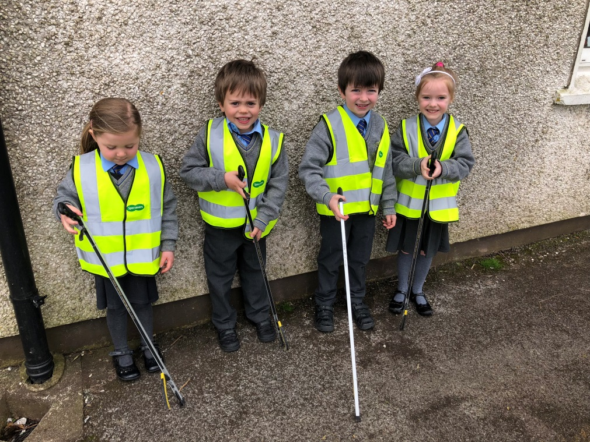
Our Junior Infant classes learned about ‘Caring for the environment’. They learned about the importance of recycling and to assist in the Upper Glanmire Community Clean Up, the children used their litter pickers to pick up litter on the school grounds.

- Energy and Forces
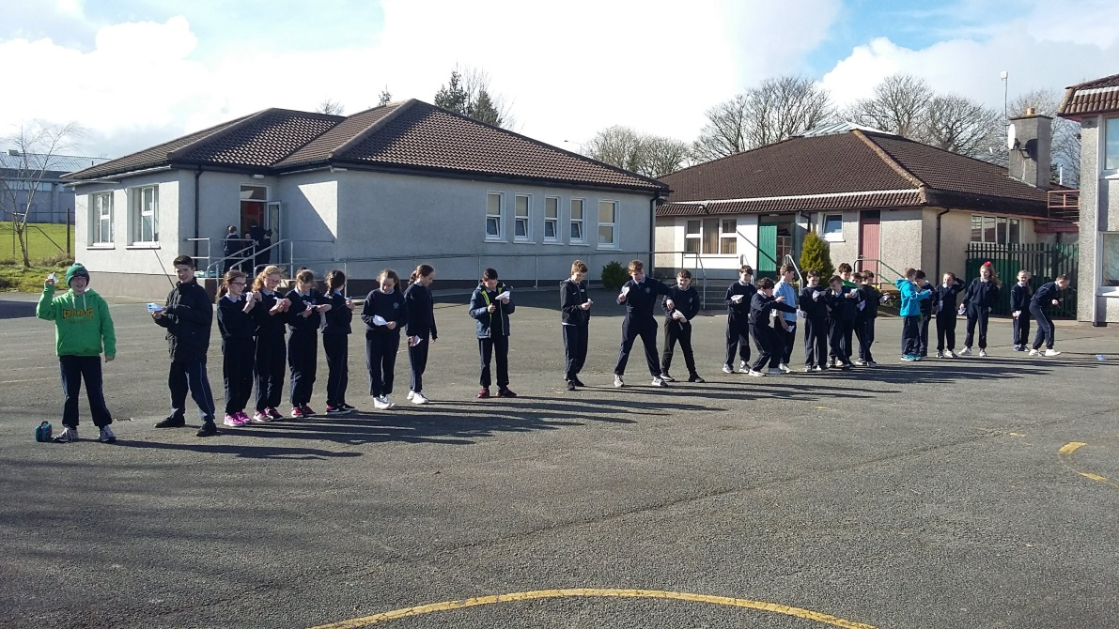
Our 5th class children learned about aerodynamics and how paper planes fly. Having learned about gravity, thrust and lift, the children created their own paper planes. They estimated how far each would fly and recorded their results based on distance. They took a video of the paper planes flying, observing and discussing afterwards why some planes flew better than others.

- Materials
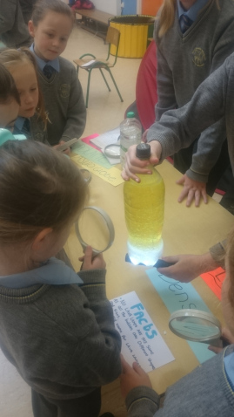
Our 6th class children created lava lamps using oil, water, food colouring and alka-selzers. They investigated how a wide range of materials may be changed by mixing and explored liquids that will not mix. They later presented this lesson to the rest of the school at their annual Science Fair.

Visit from Science speaker to our school
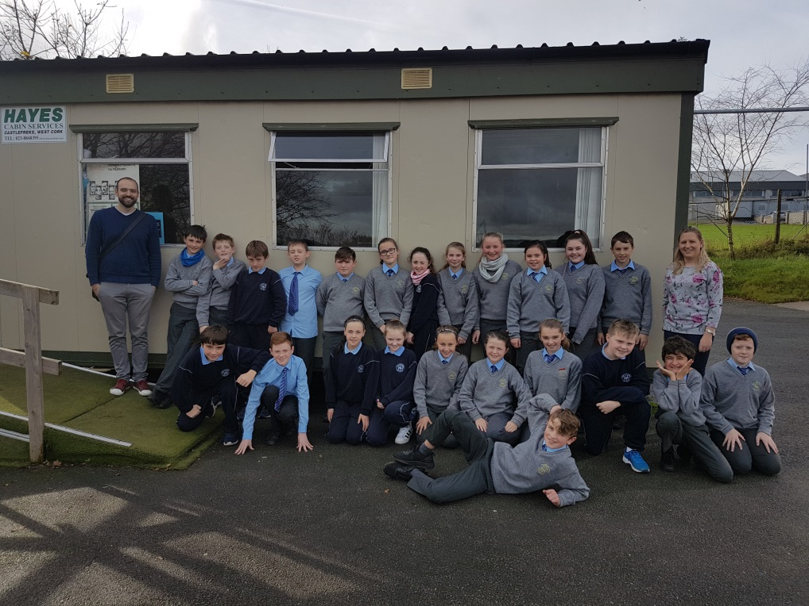
Sineád Ryan from the Tyndall National Institute came to our school with their workshop called ‘The Secret Spectrum’. Children from 3rd-6th class took part. The workshop explained the basics of light and got the students thinking about how important light is in our everyday lives from the lights on the classroom ceiling to mobile phones/tablets and the Internet. The students also had an opportunity to make their own spectroscope – a simple tool that shows them how white light is in fact made up of the colours of the rainbow.
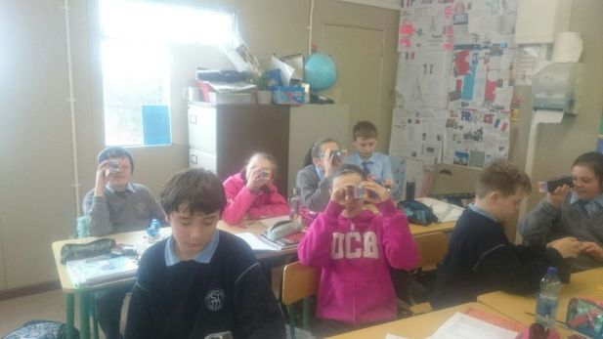
Step 2 –Technology
- Participation in the Irish Computer Society Scratch programme.
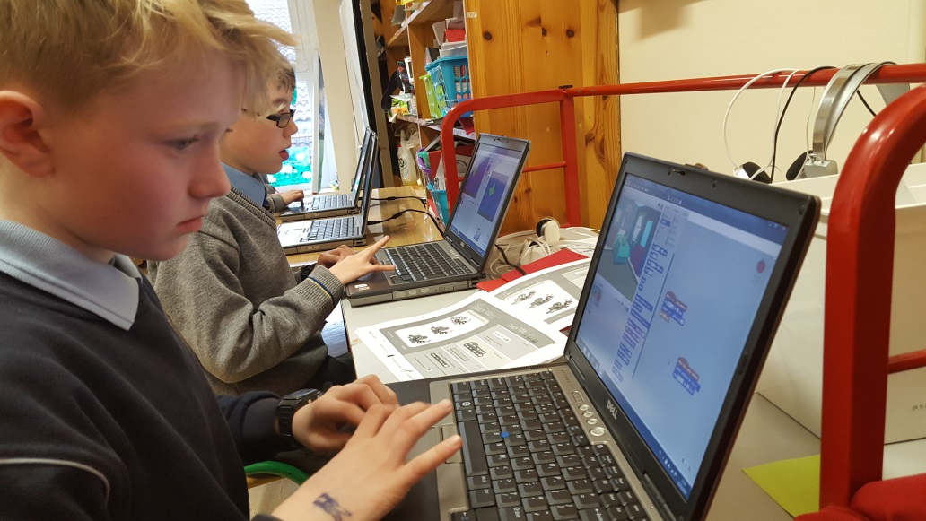
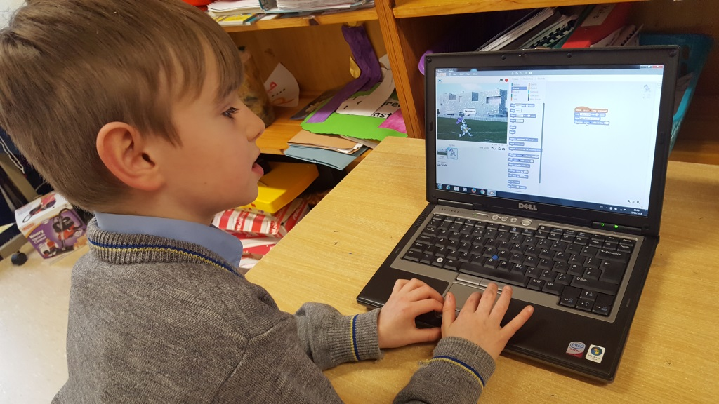
This children in 2nd & 3rd class who had already been part of our fine motor typing skills group, took part in a Scratch group where they learned about coding and programming while creating their own aminations and games.

- Used computers, laptops, iPads, iPods for classwork
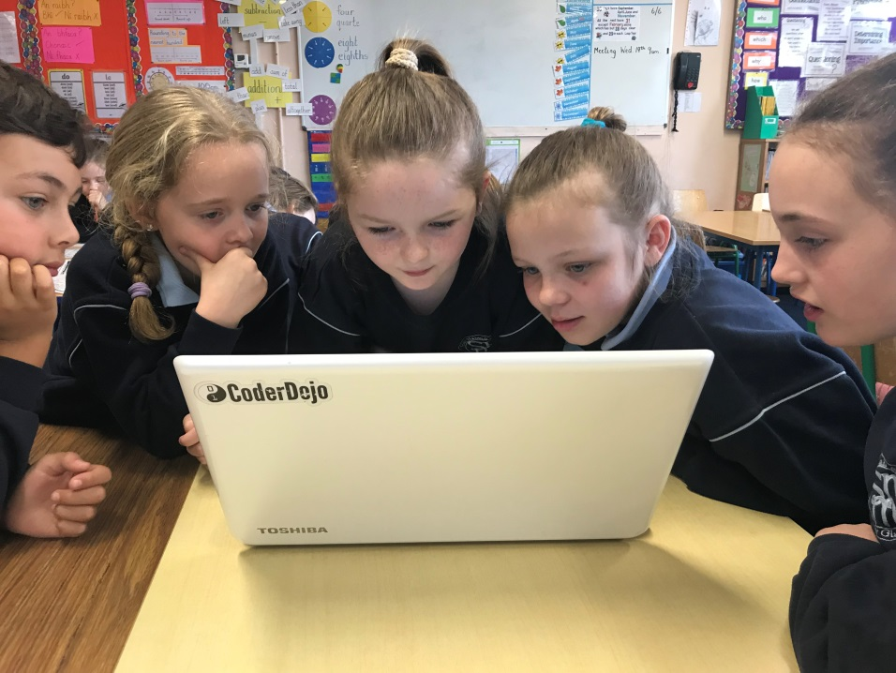
Here children in Rang 3 are using one of our school laptops to access a maths lesson on Khan Academy.

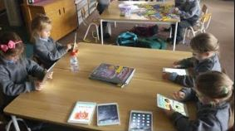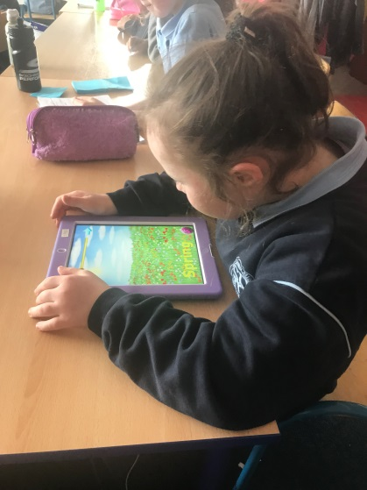

Our school has eight iPads that are stored centrally and used by all classes. Some students have their own iPads and these are used daily in classrooms. We intend on doubling the amount of iPads in the school by September 2018.
Step 3 – Engineering
- Design and make activity
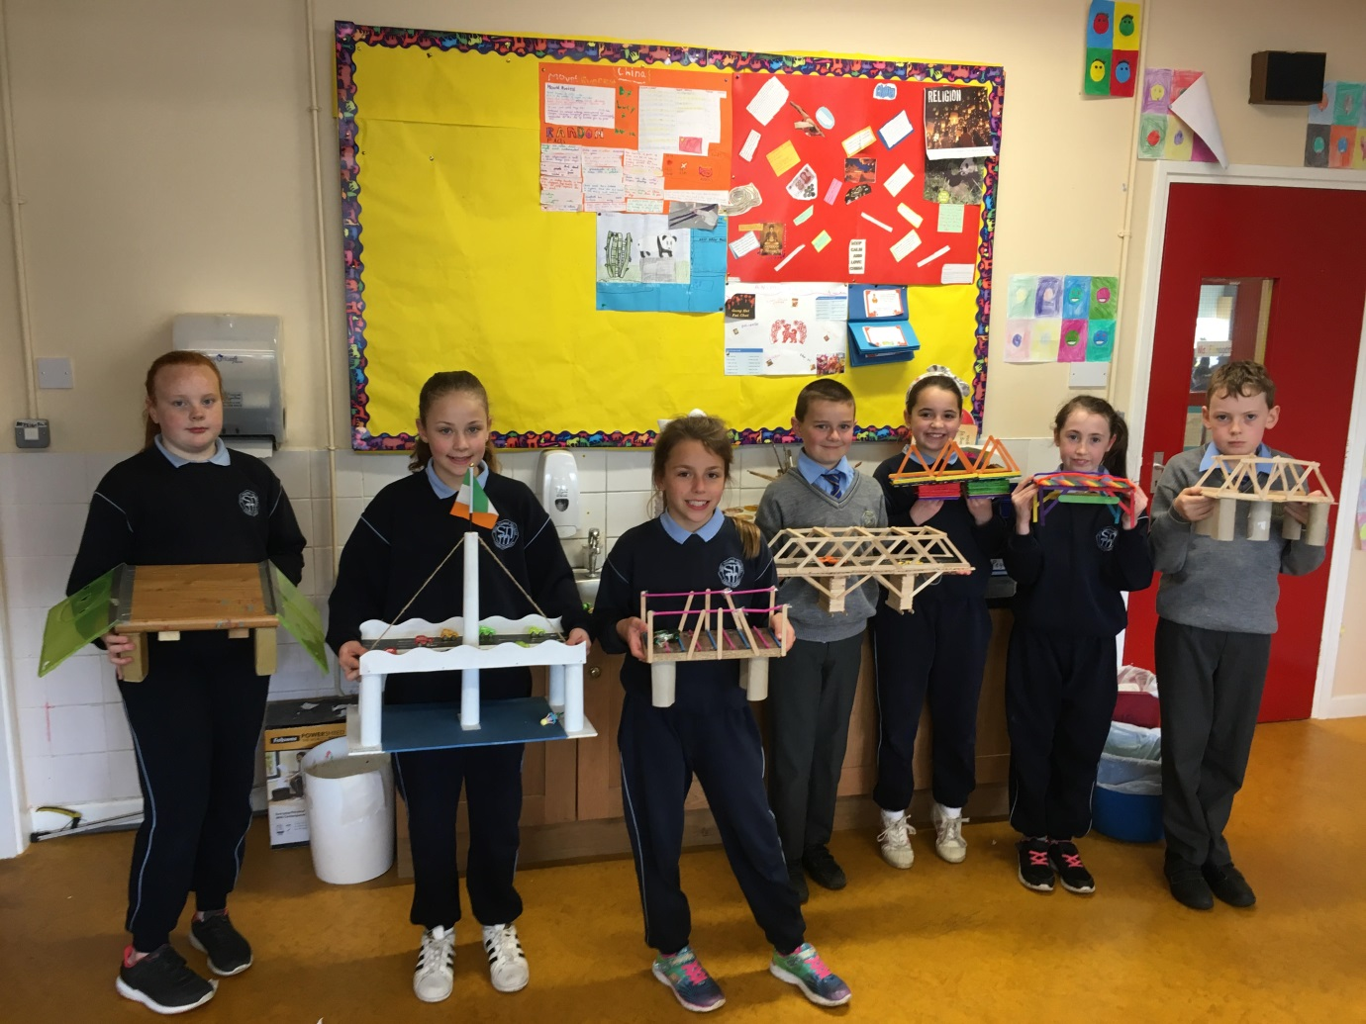
Children in 4th class learned about Engineering and how we use engineering to build bridges. Taking inspiration from bridges in our locality and famous bridges around the world, the children designed and made their own bridges and displayed them in the school.

- Invited an engineer to the school to speak to the children about his/her work.
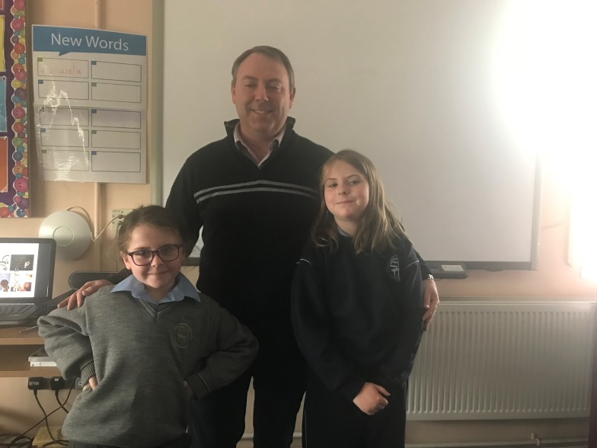
Ger Walshe of Schuff Steel visited our 3rd class children to speak with them about his work as an engineer. He brought his tools with him and the children had the opportunity to ask questions about the work of an engineer.
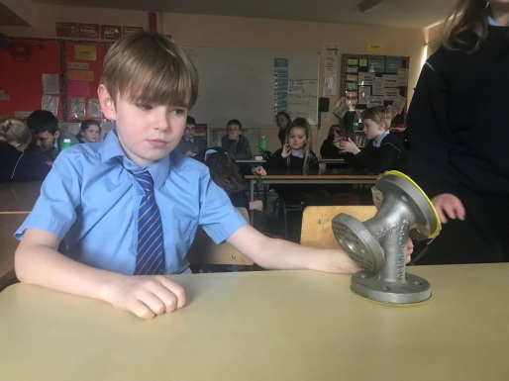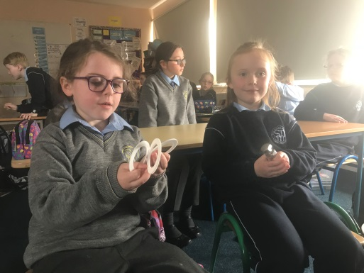
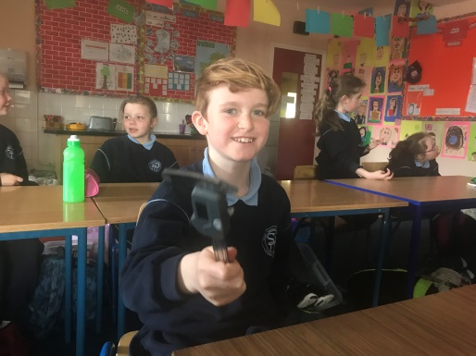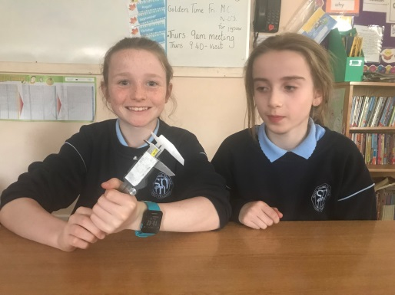

Step 4 – Maths
- Using maths skills and knowledge as part of science e.g. measuring distances, capacity and weight.
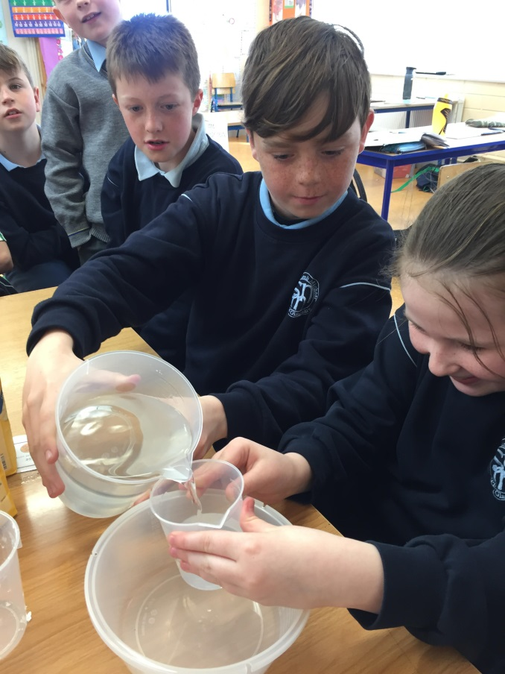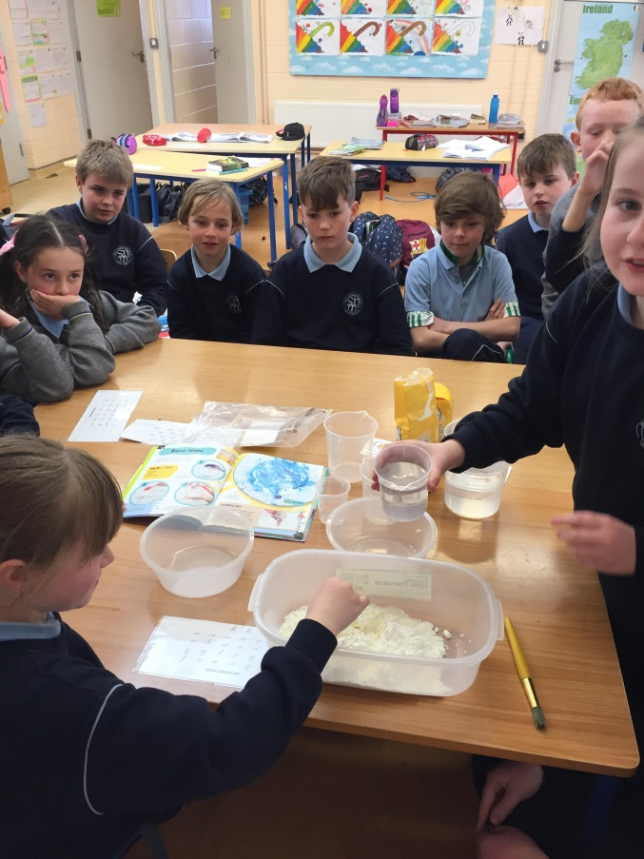
While experimenting with materials and how they change, our 3rd/4th class with the help of 1st class, used their maths skills to measure capacity during the science lesson. They were also able to use this to record their results and the materials differed depending on the amount of water used.

- Developed a maths trail around the school
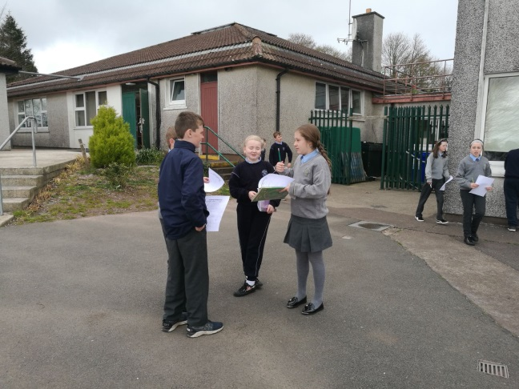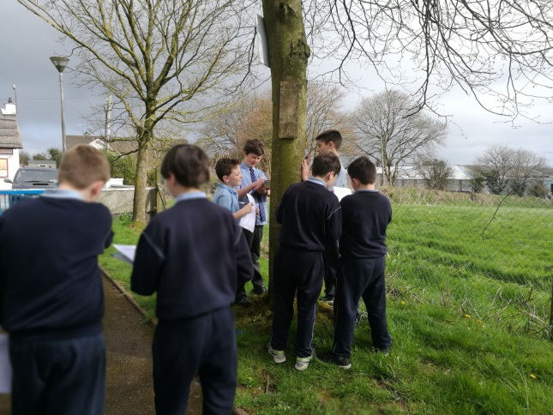
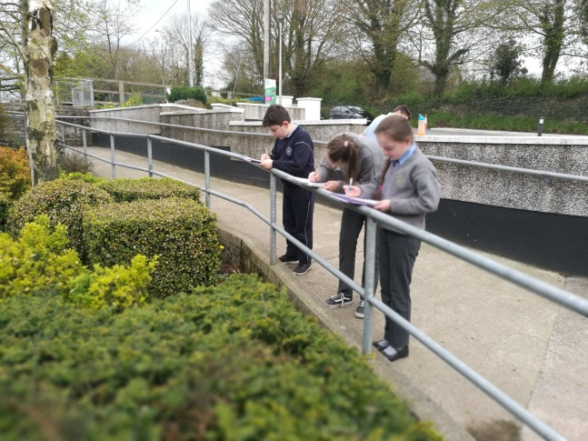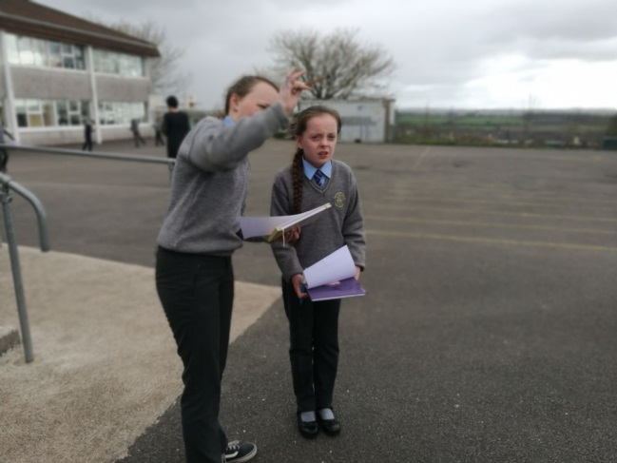

Using Croke Park hours, the teachers in the school created new maths trails across all class levels. Above you will see pictures of our 5th class children completed their maths trail.

Step 5 – STEM showcase
- Children presenting and explaining their STEM work to other classes
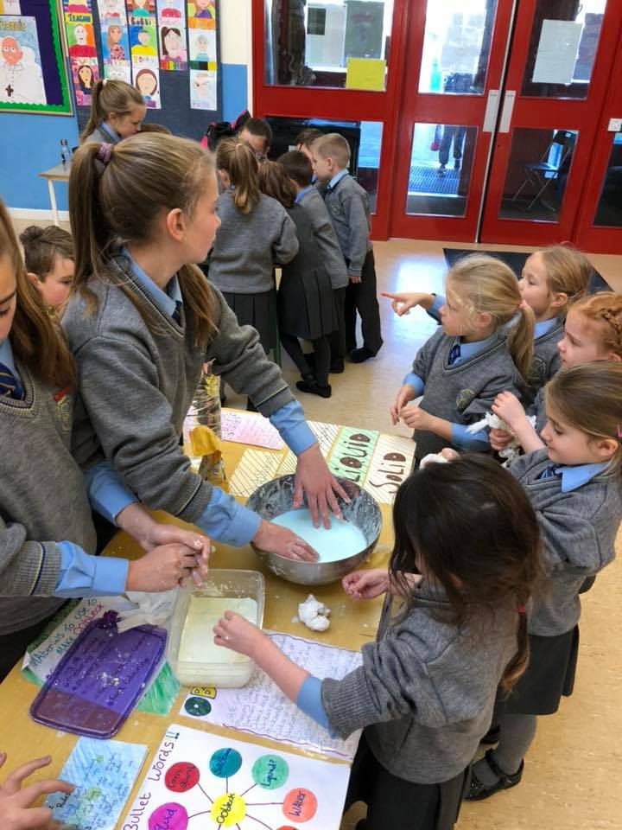
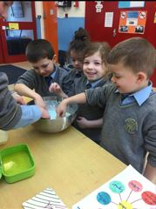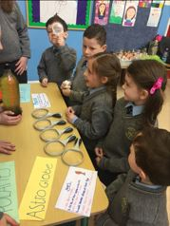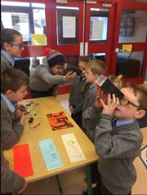
Our 6th class children held their annual Science Fair in the school hall. They invited all other classes to attend. Their stations included lava lamps, plasma balls, circuits, oobleck, magnets, optical illusions and refraction and reflection. Children used the technology available in the school throughout the day and used their maths skills recording at a number of the stations.

